Table of Contents

Task 1 2

**Home Page** 7

**Contact Us Page** 8

**About us page** 9

**Q&A PAGE** 11

**Registration page** 12

**Our Drivers Page** 13

**Task 2** 16

**CSS** 16

**Text search** 54

**Task 3** 55

**Home page W3C validation Check** 55

**Contact us page W3C Check** 56

**About us W3C Check** 57

**Q&A page W3C Check** 57

**Register Online page W3C Check** 58

**Our drivers page W3C Check** 59

**Screen reader testing** 61

**Website Test on two Browsers** 66

**A report evaluating the testing** 69

**Task 4** 71

**A report about the vintage rally club website** 71

References 74

# Task 1

Website Usability in **chrome browser**

Fig1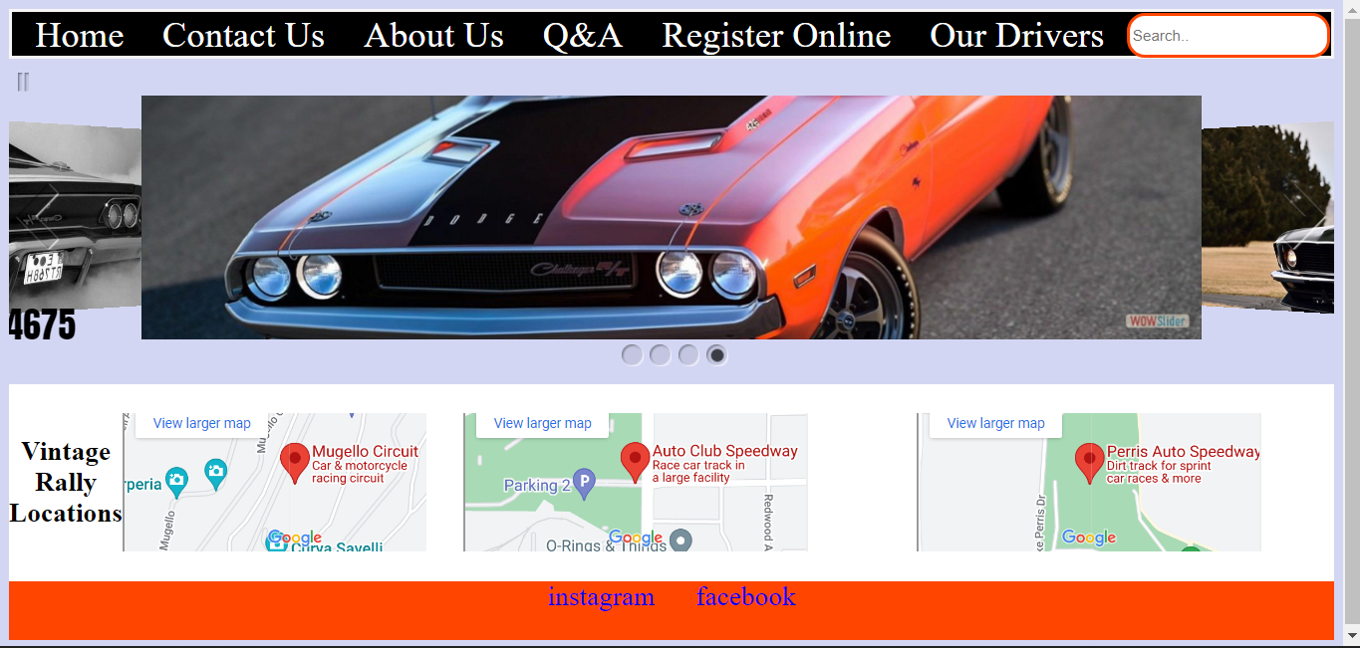

Website usability in **Firefox Browser** Fig2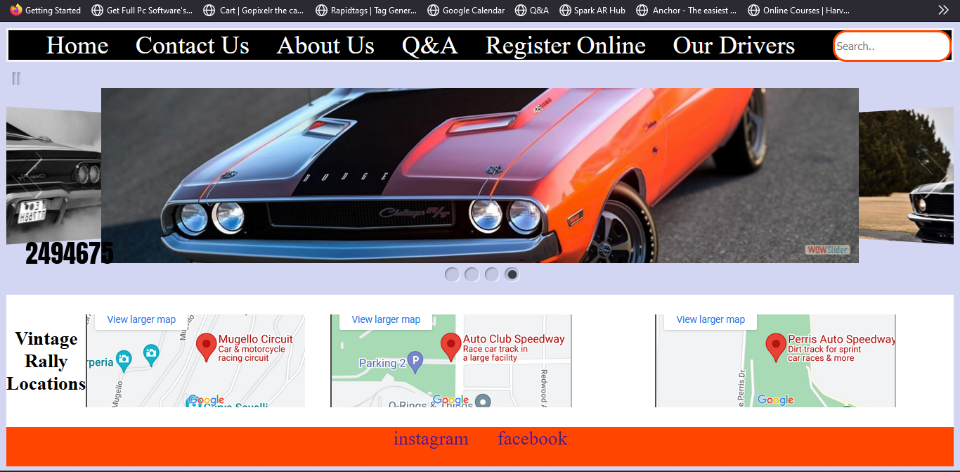

**Pictures used in the website**. Fig4

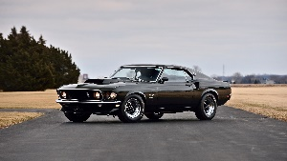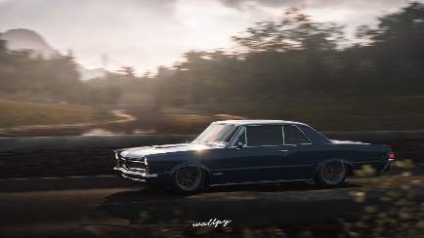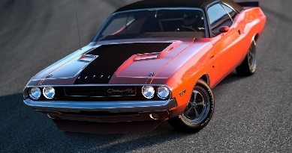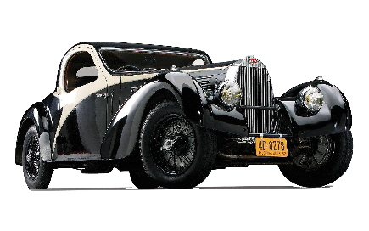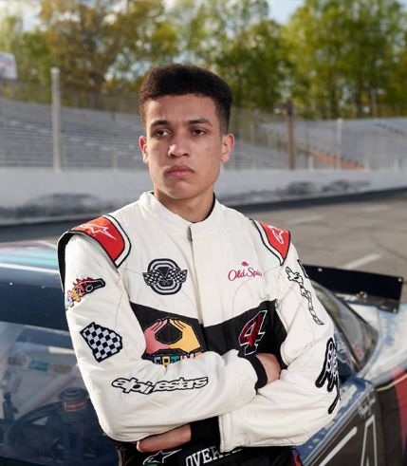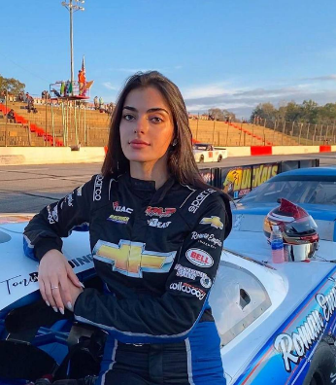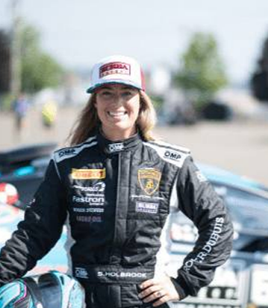

Home Page fig5

The home page which includes a navigation bar, slider, map and footer with social media links

Contact Us Page fig6

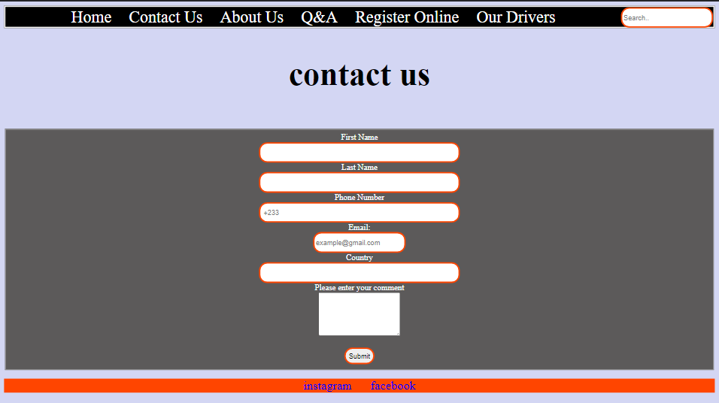

Contact us page which contain a form with the following**; first name, last name, phone number, email** and **comment**

About us page fig7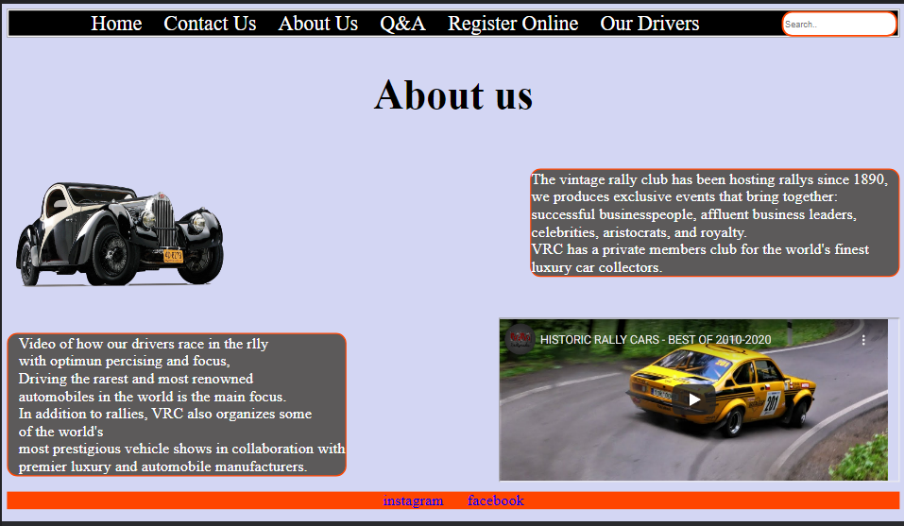

About us page contain texts and relevant multi-medias

Q&A PAGE fig8

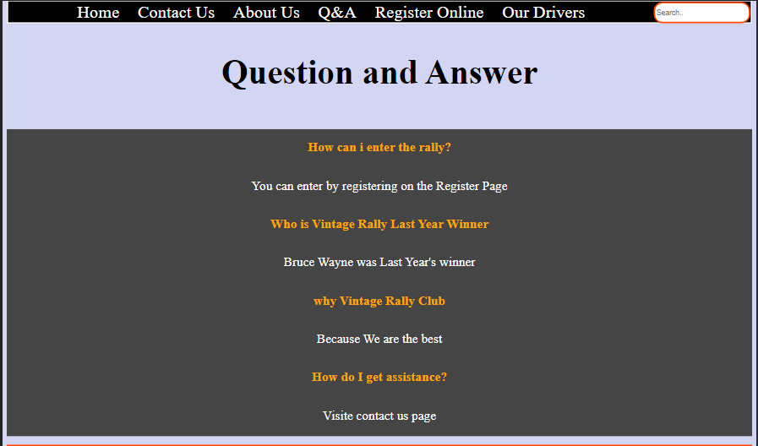

Question and answer contains relevant information for vintage rally website

Registration page fig9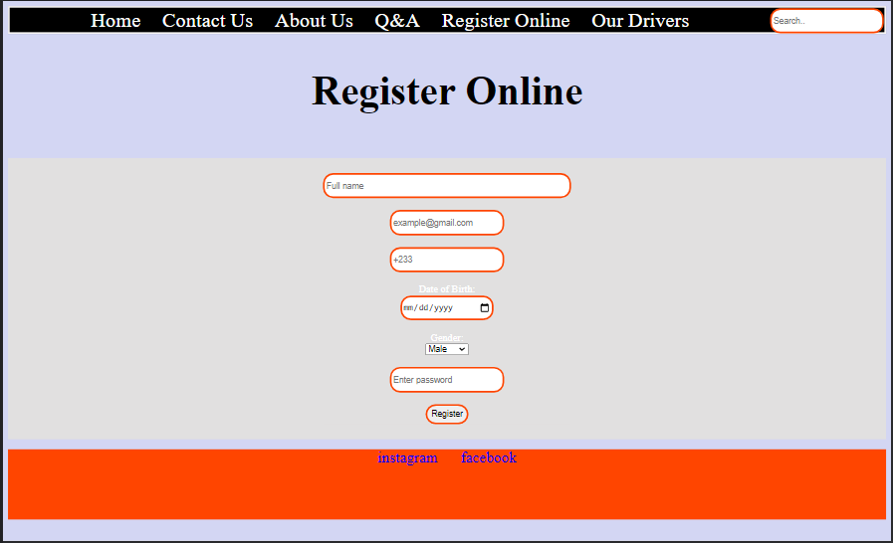

“This page also has a form with the following; **full name, email, phone number, date of birth, gender, password**

Our Drivers Page fig10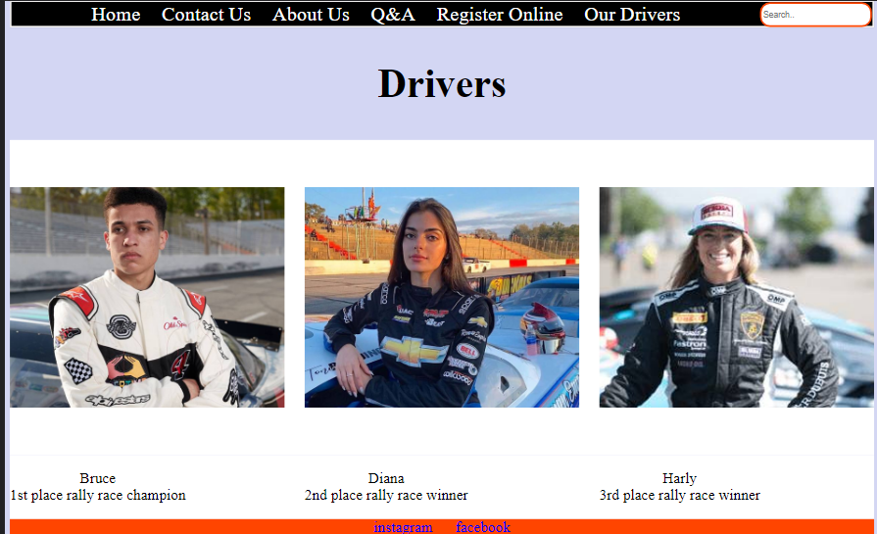

This contains all the drivers with a hover

# Task 2

**External CSS link**

 <link href="style.css" rel="stylesheet" type="text/css" />

# CSS

    html {

        scroll-behavior: smooth;

    }

    nav {

        text-align: center;

        width: 100%;

        border: 3px solid rgb(246, 244, 244);

        box-sizing: border-box;

        background-color: black;

    }

    nav a {

        font-size: 2rem;

        margin: 0 15px;

        text-decoration: none;

        color: white;

    }

    nav a:hover {

        color: orangered;

    }

    .search {

        float: right;

    }

    body {

        background-color: rgb(211, 214, 243);

        color: black;

    }

    .container {

        display: grid;

        height: 90vh;

        grid-template-rows: 1.2fr 1fr .3fr;

    }

    .tab {

        display: flex;

        align-items: center;

        width: 100%;

        gap: 2rem;

        background-color: white;

    }

    .Crd:hover {

        transform: scale(1.1);

        border: solid 2px orangered;

    }

    .Crd {

        width: 50%;

        height: 70%;

        display: flex;

        align-items: center;

        overflow: hidden;

        z-index: 0;

        text-align: center;

    }

    .Crd img {

        width: 100%;

        height: auto;

    }

    footer {

        display: inline-block;

        width: 100%;

        text-align: center;

        background-color: orangered;

    }

    footer a {

        margin: 0 1rem;

        font-size: 1.5rem;

        text-decoration: none;

    }

    footer a:hover {

        color: white;

    }

    .reg {

        display: grid;

        place-items: center;

        background-color: rgb(225, 224, 224);

        color: white;

    }

    .reg1 {

        display: grid;

        place-items: center;

        background-color: rgb(70, 69, 69);

        color: white;

    }

    .container2 {

        display: grid;

        height: 90vh;

        grid-template-rows: .3fr 1.2fr .3fr;

        gap: 1rem;

    }

    h1 {

        text-align: center;

        font-size: 4rem;

    }

    fieldset {

        display: grid;

        place-items: center;

        background-color: rgb(92, 90, 90);

        color: white;

        text-align: center;

    }

    .container3 {

        display: grid;

        height: 90vh;

        grid-template-rows: .2fr 1fr 1fr .3fr;

    }

    .w1 {

        float: right;

        padding-right: 1rem;

    }

    .w2 {

        float: left;

        padding-left: 1rem;

    }

    .yt {

        float: right;

        padding-right: 1rem;

        max-width: 100%;

    }

    .container4 {

        display: grid;

        height: 90vh;

        grid-template-rows: .1fr 2fr 1fr .3fr;

    }

    h2 {

        color: orange;

    }

    h1:hover {

        transform: scale(1.1);

    }

    h2:hover {

        transform: scale(1.1);

    }

    p {

        font-weight: 500;

        font-size: 1.5rem;

    }

    input {

        border: 3px solid orangered;

        border-radius: 1rem;

        height: 2rem;

        width: auto;

    }

    .CP {

        font-weight: bolder;

    }

    .w {

        background-color: rgb(92, 90, 90);

        color: white;

        border-radius: 1rem;

        border: double 2px orangered;

    }

Text search fig11

The search bar is located on the nav bar .



Right corner

# Task 3

# Home page W3C validation Check

fig12

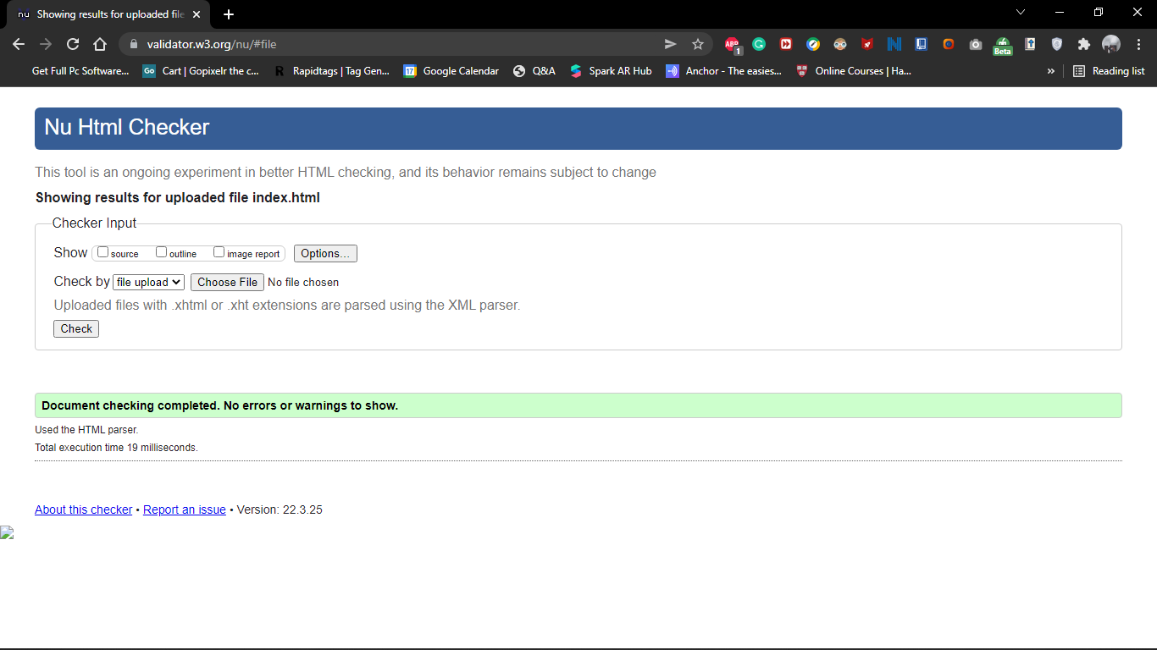

**No errors found**

# Contact us page W3C Check

ig13

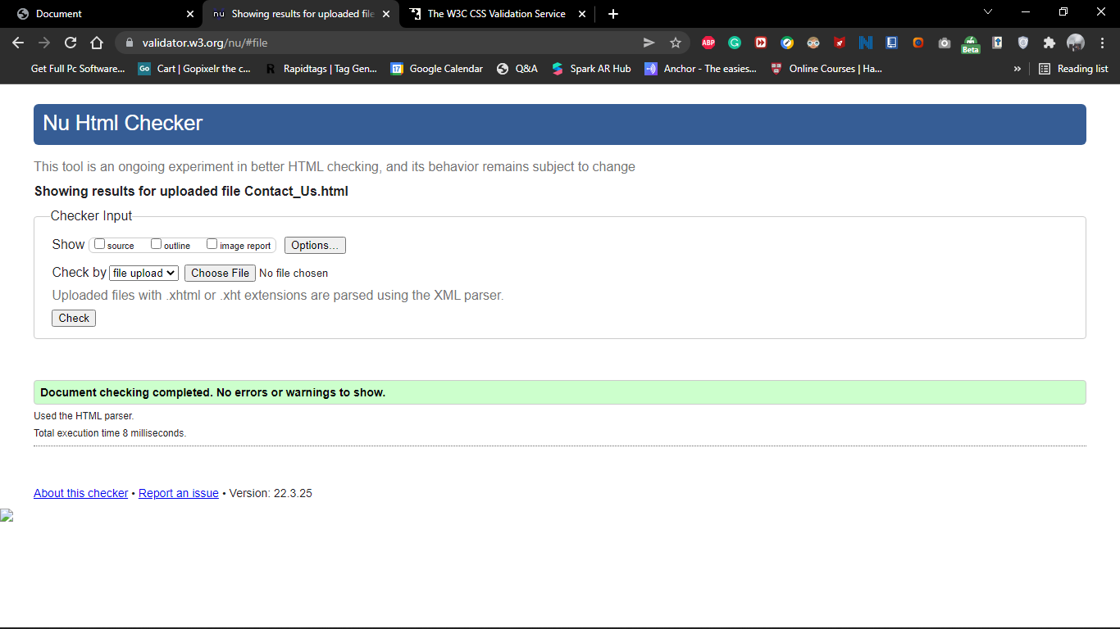

**No errors found**

# About us W3C Check

fig14

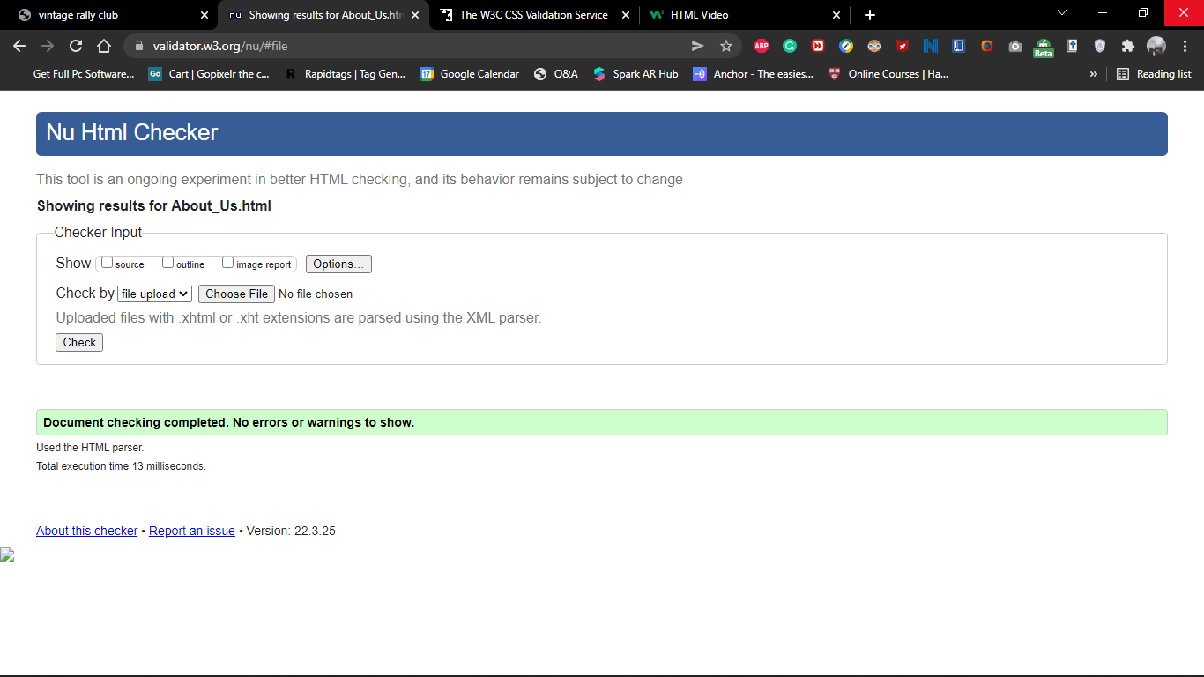

**No errors found**

# Q&A page W3C Check

fig15

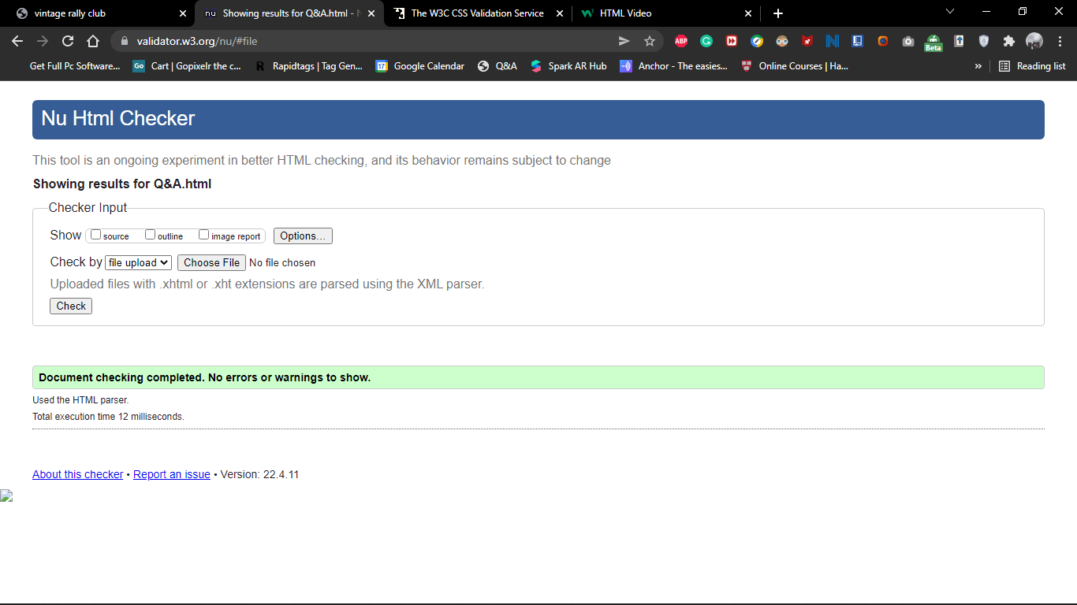

**No errors found**

# Register Online page W3C Check

fig16

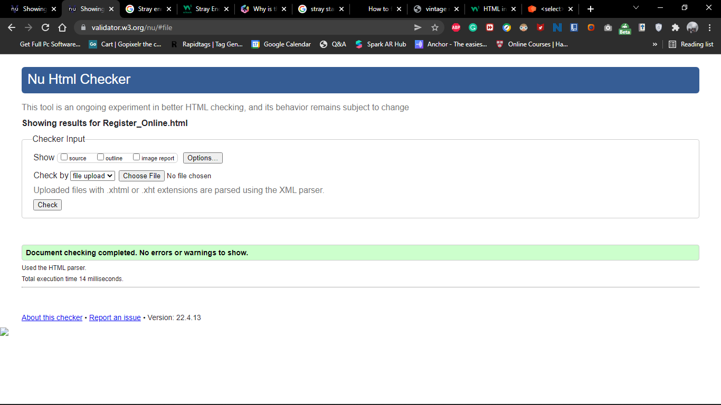

**No errors found**

# Our drivers page W3C Check

fig16

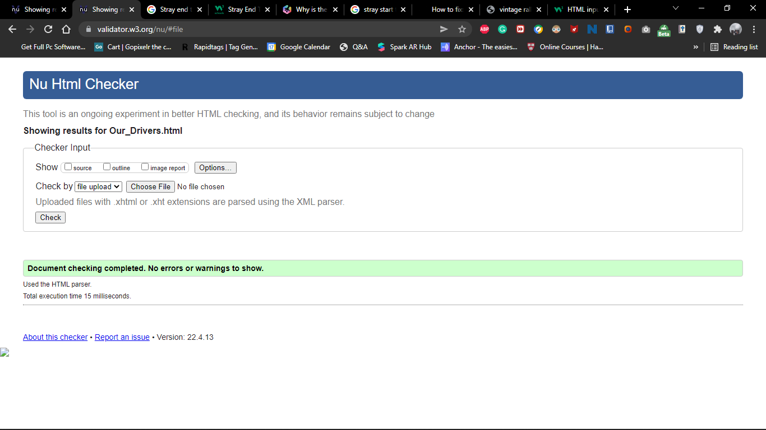

**No errors found**

**VINTAGE RALLY CSS VALIDATION**

fig17

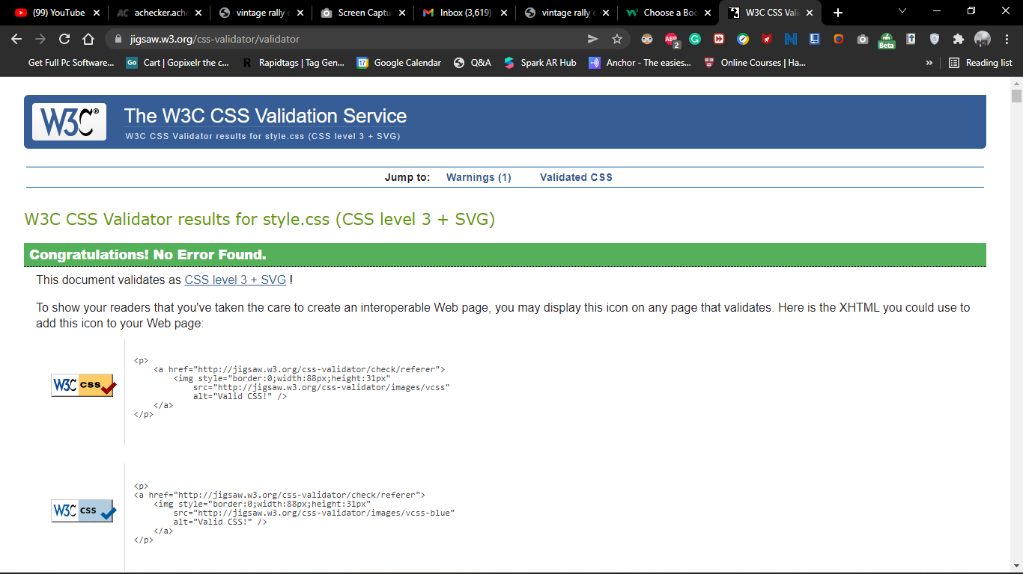

**No errors found**

# 

# Screen reader testing

The vintage rally club website screen reader test was carried out using the native **windows 10 screen reader**

**Windows 10 screen reader**

fig18

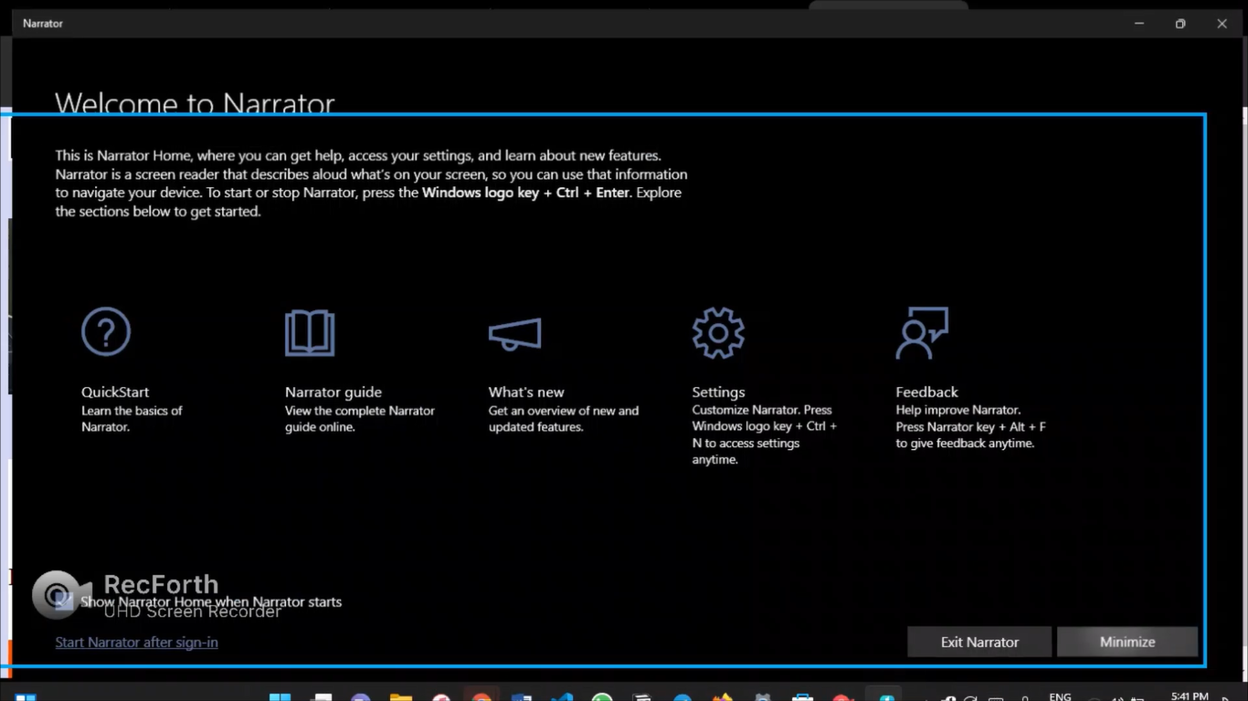

**Screen reader mentioning the navigation bar**

fig19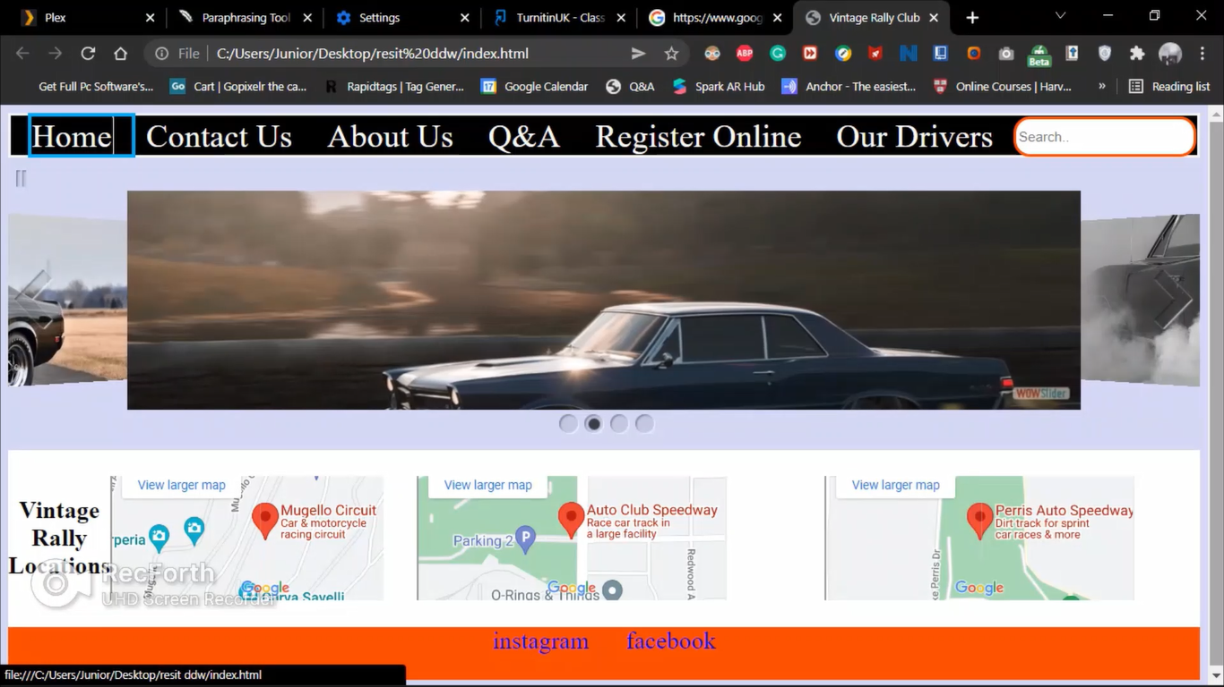

**Screen reader mentioning the image description**

Fig20

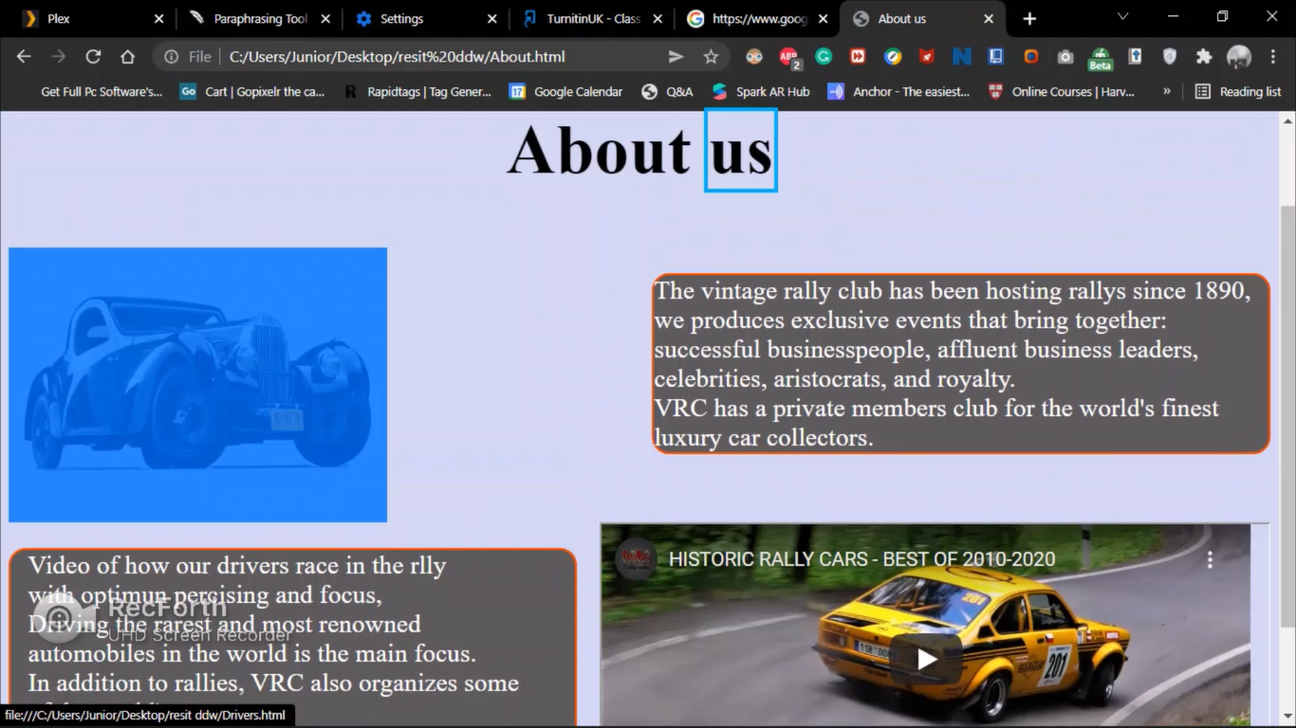

**Screen reader reading the header and paragraphs on the website**

Fig21

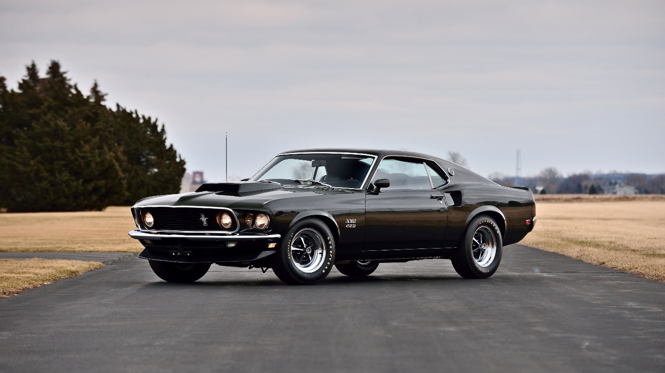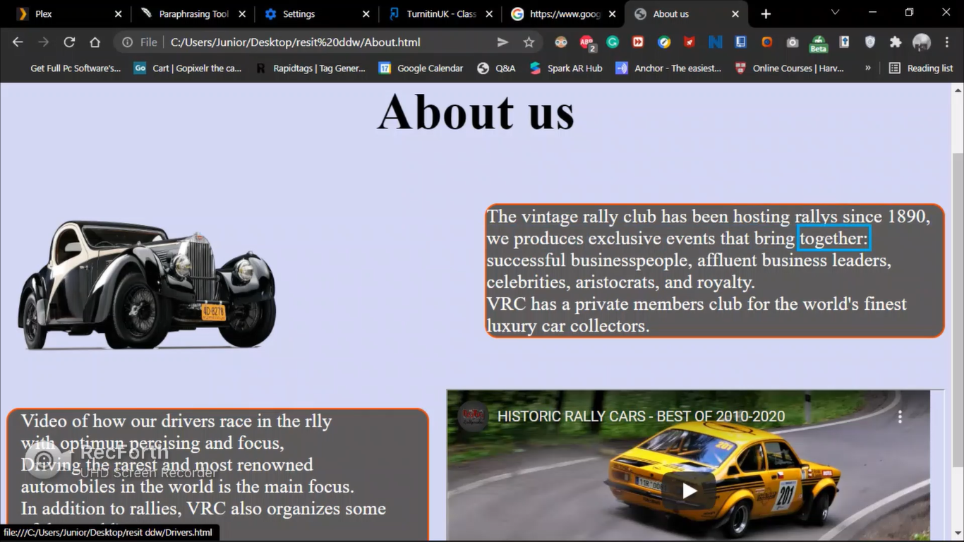

**Findings from the test**

* All the access keys were mentioned by the screen reader
* Pictures with ALT descriptions were also mentioned by the screen reader

**Accessibility Test**

The vintage rally club website accessibility test was carried out using

**A – checker** using the WCAG 1.0 standard

**Home page**

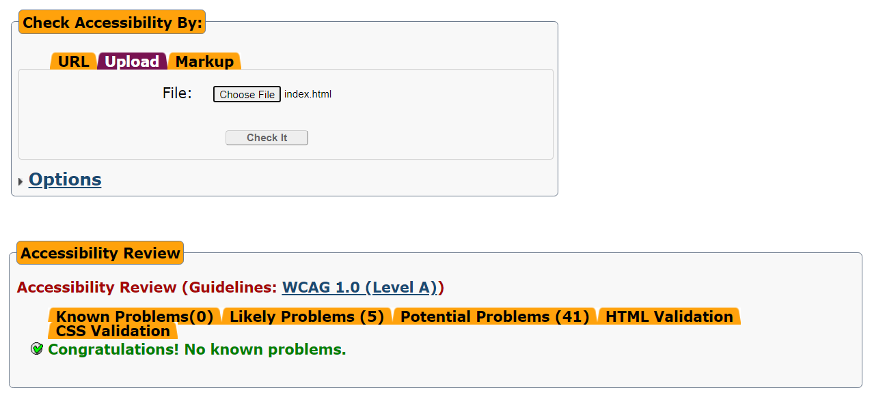

**About page**

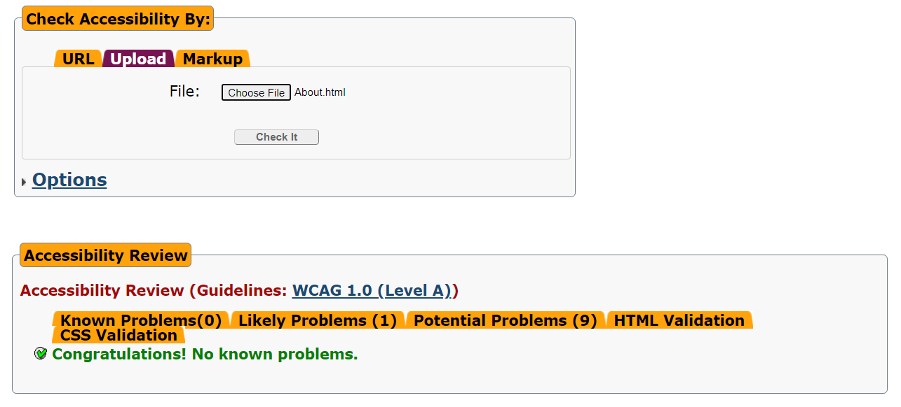

**Contact page**

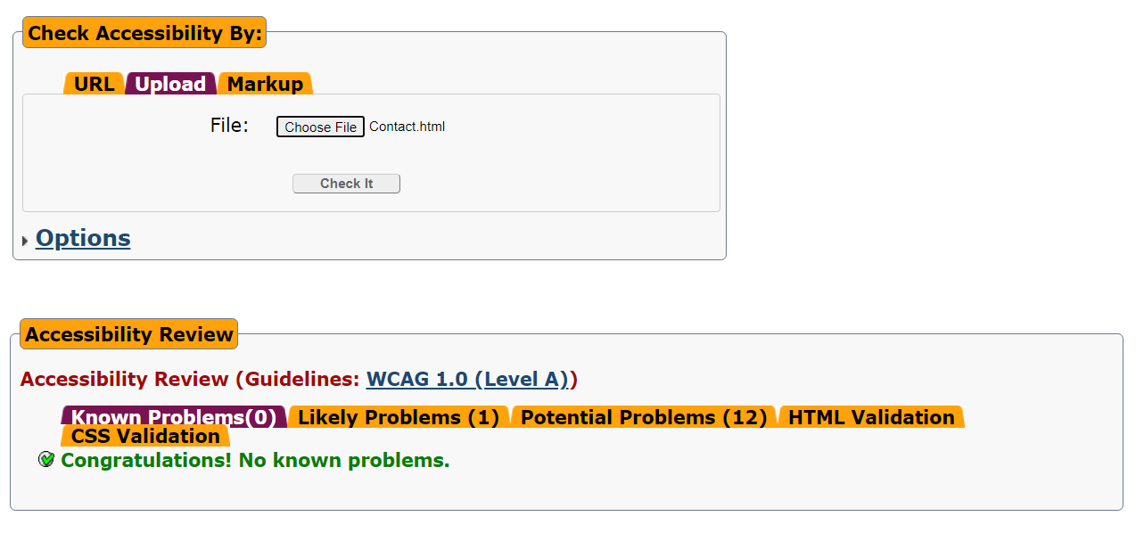

**Drivers page**

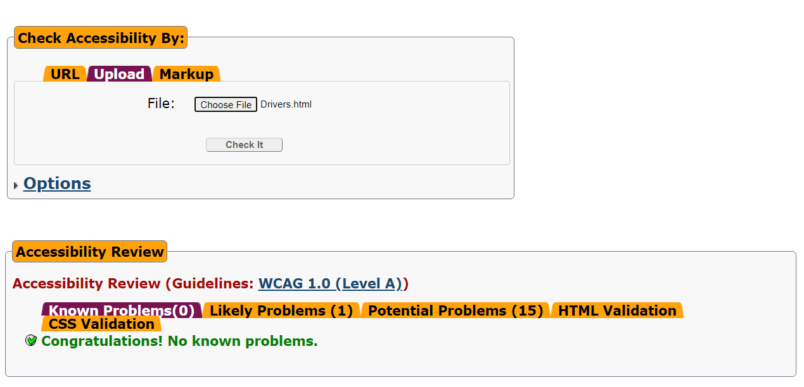

**Question and answer page**

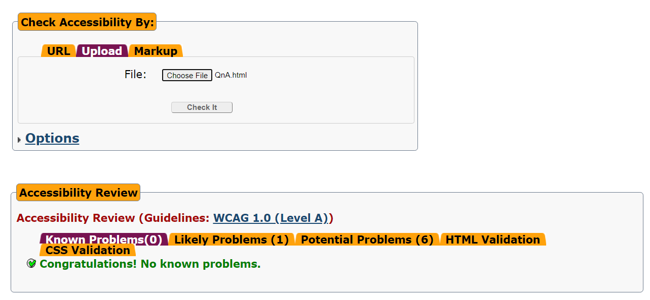

**Register page**

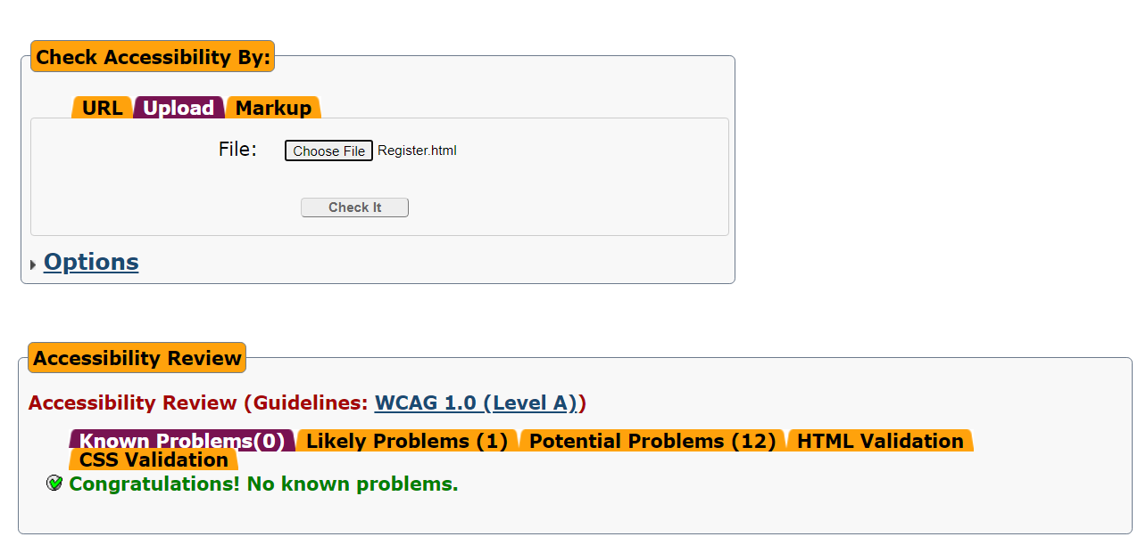

**How the vintage rally club website works for disabled users**

1. It has keyboard accessibility that allows for easy navigations. The keyboard accessibility in the vintage club rally website are ;

* “Alt + **h**” to go to the **H**ome page
* “Alt + **c**” to go to the **C**ontact us page
* “Alt + **a**” to go to the **A**bout us page
* “Alt + **q**” to go to the **Q**uestion and answer page
* “Alt + **r**” to go to the **R**egister page
* “Alt + **o**” to go to the **O**ur drivers page

1. It contains relevant images and videos that help in visualizing and understanding the information on its pages
2. The fonts size used are large and bold which allows for easy reading
3. The forms pages use large inputs, placeholders and ‘required’ attributes to help users when filling it
4. The image ‘ALT’ attribute contains the descriptions of the images which helps when using a screen reader

# Cross Browser Test

**Chrome Browser** fig22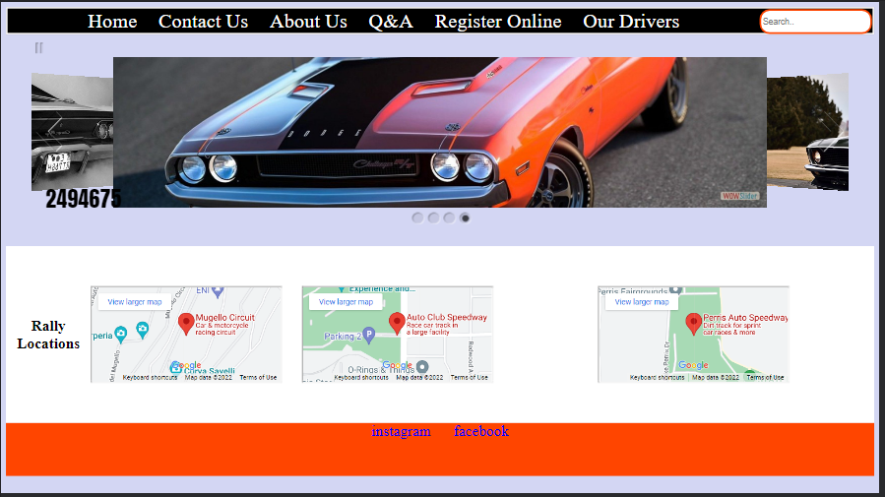

**Firefox Browser** fig23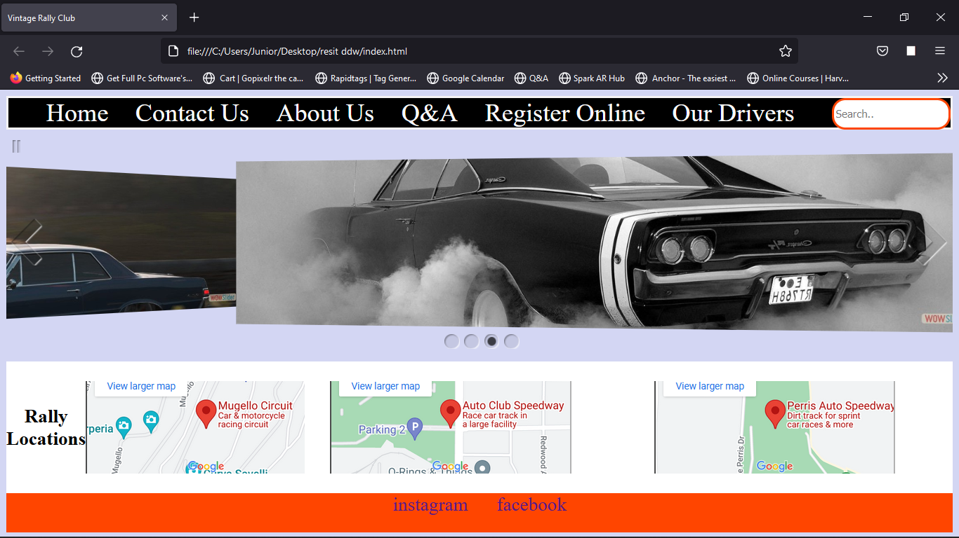

**Analysis of the test**

From the observation, the website appears the same on both browsers

**Summary**

No discrepancies were found. The website looks and functions the same on both browsers

# A report evaluating the testing

**Introduction**

This report provides a detailed assessment of all test on the vintage rally club website, containing; unresolved issues during testing and recommendations for how they can be resolved.

**unresolved issues**

There were no unsolved issues found In the testing. All the tests carried out the on the vintage rally club website are;

* W3C validation testing
* Accessibility testing
* Screen reader testing
* Testing on other browsers

All tests were successful with no errors

**Recommendations for unsolved issues**

There are no recommendations since all the test were successful

**The role of the World Wide Web Consortium (W3C)**

* They are the guardians of the numerous standards such as HTML,CSS, DOM, XHTML and XML that are utilized on the internet (Jordan, 2013).
* They have tests that allow developers to see if their html or CSS is compliant with their standards.
* They modify and make new standards, and they largely determine the direction that the World Wide Web will take (W3.org, 2022).
* They create norms and criteria to ensure the web's long-term development

**Conclusion**

From the information above, the vintage rally club website was successful in all the testing.

# Task 4

# A report about the vintage rally club website

**Introduction**

This report provides an analyzation of the vintage rally club website. The following are some of the report highlights;

Evaluation of accessibility features

The vintage rally website has implemented numerous accessibility features. Some of them are;

* **Keyboard accessibility** – user can use keyboard accessibility to navigate across pages for example, “Atl + h” is to get to the home page and “Alt + c” is to get to the contact us page
* **Effective use of images and colours** - The vintage rally club website uses a colour scheme which makes it very easy to read, also, relevant images are used to help visualize the information’s on the page.

Embedded multimedia components

The embedded multimedia on the vintage rally club website, will allow site visitors to get more information about vintage rally through videos.

Furthermore, it also helps site visitors with cognitive disabilities (Hadley, 2016).

An example of the embedded multimedia is on the **About page**.

How the Vintage Rally club can use the internet as a business tool

The following are ways the website can be used as a business tool;

* **Helps in customer communication** – customers can contact vintage rally club through the website which will help boost customer satisfaction. Also, vintage rally can convey information on the website that customers need, for example the question and answer page displays questions mostly asked by customers with answers.
* **Customer insights**- Through the website, the vintage rally club will be able to know valuable insight that can help the company. Insights like which rally location is preferred, where rally customers are located and the amount of people who visit the website
* **Helps in business strategies** – because of all the information the vintage rally club will gain through the website, this will enable them to make smart business decisions that will help it grow

Recommendations for website improvements

* **Dark mode**- a dark mode feature on the vintage rally website would help reduce customer eye strain
* **Payments and booking –** adding a payments and bookings page can improve the convenience of the rally club website
* **Adding more accessibility features - more** accessibility feature will make it easier for all kinds of customers to access the page

Conclusion

All the information listed above is a complete analysation on the website and how it can help vintage rally club.

# References

Hadley, C., 2016. *Small Business - Chron.com.* [Online]   
Available at: https://smallbusiness.chron.com/advantages-using-multimedia-design-27608.html  
[Accessed 18 4 2022].

Jordan, 2013. *bop-admin.* [Online]   
Available at: https://www.bopdesign.com/bop-blog/2013/06/the-importance-of-w3c-standards/  
[Accessed 18 4 2022].

W3.org, 2022. *W3.org.* [Online]   
Available at: https://www.w3.org/Consortium/mission#:~:text=The%20W3C%20mission%20is%20to,term%20growth%20of%20the%20Web.  
[Accessed 16 04 2022].